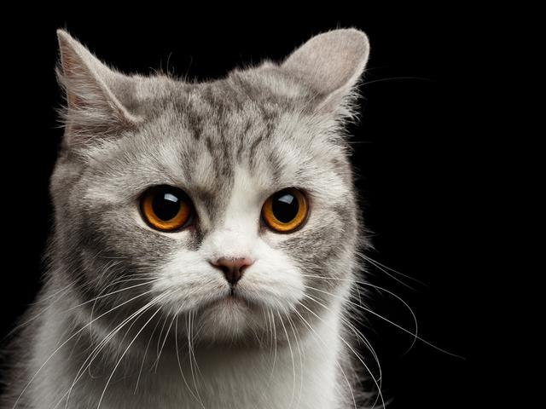

<img src= “https://www.google.com/search?q=gambar+kucing&safe=strict&rlz=1C1WHCN_enID781ID805&tbm=isch&source=iu&ictx=1&fir=oKM1hfmY34yyMM%252CDpDQTRp7h_9CWM%252C%252Fm%252F01yrx&vet=1&usg=AI4_-kR8s7y6PEC3l8VCKdyM6hQIRORgEw&sa=X&ved=2ahUKEwj5lMz29oXxAhVJbysKHZNzC9kQ_B16BAgLEAE&biw=1366&bih=600#imgrc=oKM1hfmY34yyMM”alt="Cat" />